Experiment No: 3

Title: Implement control structures and form validation; create a grading system based on user-entered marks.

Software/Tools Required: Visual Studio Code (or any text editor), Web Browser (Google Chrome, Microsoft Edge, Firefox, etc.)

Theory:
JavaScript provides different control structures and variable declaration methods to build interactive web applications.
1. if-else Statement
- Used to make decisions based on conditions.
- Executes different blocks of code depending on whether the condition is true or false.
2. switch Statement
- Used when multiple conditions need to be checked.
- Executes the matching case based on the given expression.
3. Loops
- for: Repeats code for a fixed number of iterations.
- while: Repeats code while a condition is true.
- do-while: Executes the code at least once before checking the condition.
4. Form Validation
- Ensures that user inputs are valid before processing.
- Checks for empty fields, valid ranges, and correct data types.
Student Grading System
A Student Grading System is a JavaScript application that accepts student details and marks, validates the input, calculates the total and percentage, assigns grades using control structures, and displays the final result dynamically.
Output:
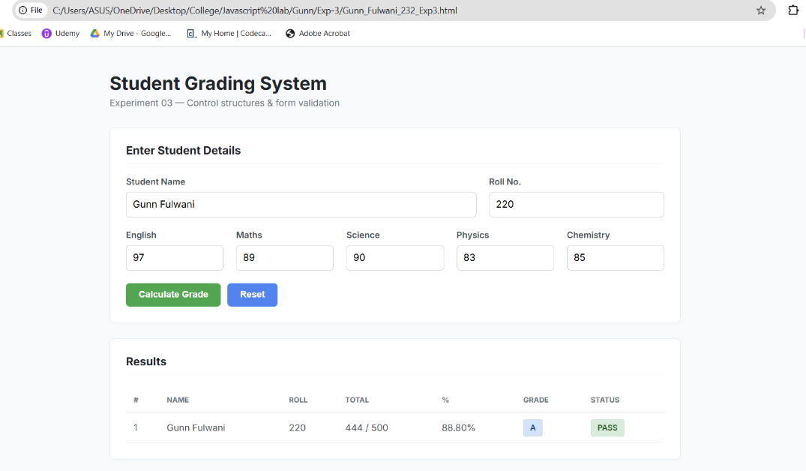
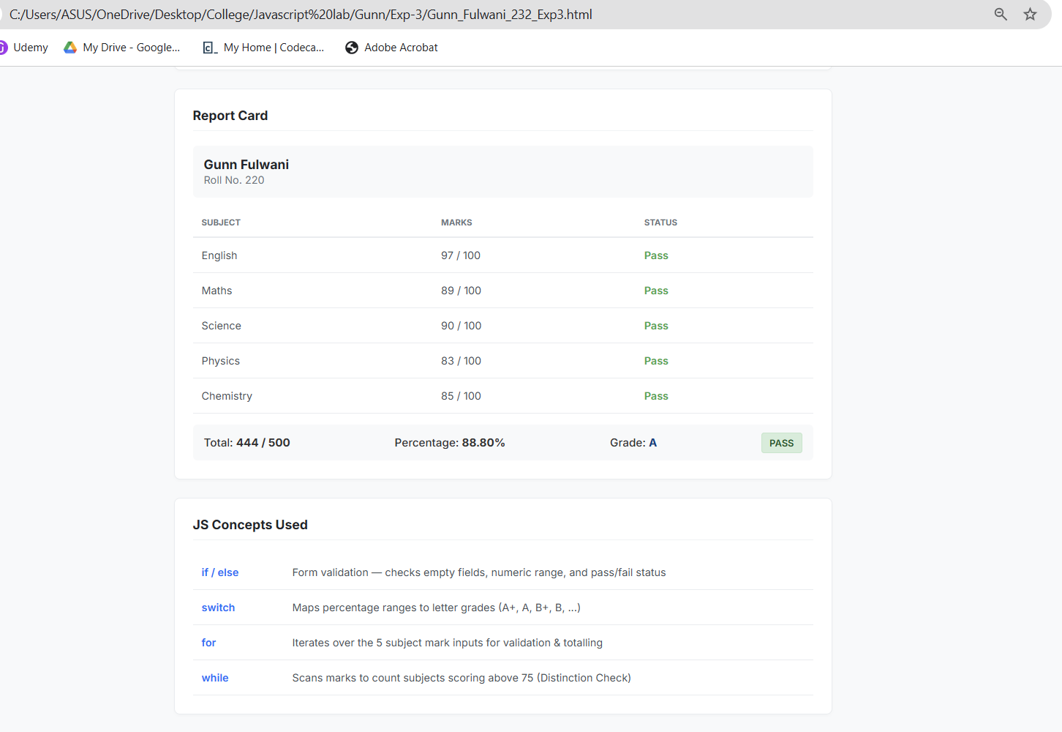

Result/Conclusion (Corrected): The experiment was successfully completed. Various JavaScript control structures (if-else, switch, for, and while loops) were practically implemented to build a dynamic Student Grading System. Form validation was successfully applied to ensure accurate user inputs and prevent blank or out-of-range values. The application correctly calculated totals, percentages, and dynamically assigned grades and pass/fail statuses based on complex decision-making logic.

